Group: Chathuni and Urvashi

Pacman game design documentation.

**Step 1: Decomposition**

Purpose:

* To create a Pacman game which is smooth, fast and responsive where players can control Pacman to eat kibbles in a maze without running into ghouls.

Description:

* We will start by making walls, Pacman, a maze, and ghouls to set up the game. Set Pacman movement, ghoul movement, and collision detection. Tracking the score, lives and display on the screen.

**Step 2: Form design**

* At the beginning of the game, the design layout will display walls, Pacman, maze, and ghouls.
* It will display both current score and lives.

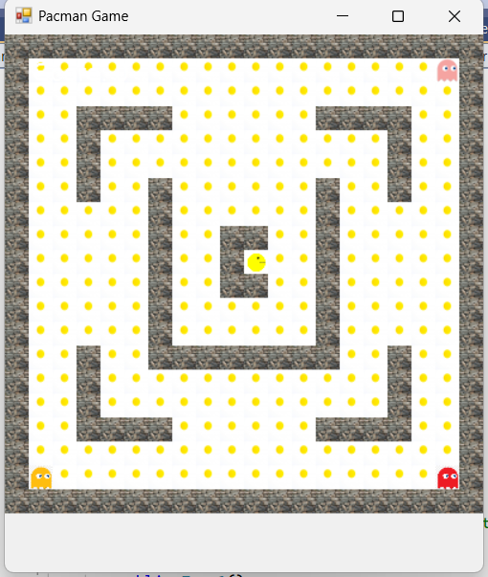

At the bottom of the game we will add a score and lives option when coding.

**Controls and components:**

* Pacman Movement (Player Character): Use arrow keys to move Pacman up, down, left, and right.
* kibble: It is placed throughout the maze. When Pacman eats a kibble, it disappears, and the score increases.
* Ghouls: Ghouls move through the maze trying to catch Pacman. Each ghoul has a different movement pattern
* Score display: Displays the current score, which increases when Pacman eats kibbles and ghouls.
* Timer: Manages game loops and timing for power-up durations and ghoul behaviour patterns.
* Game over message: Displays when Pacman loses all lives.
* Game won message: Displays when Pacman eats all the kibbles.

**Step 3: Abstraction**

Identify the classes, I am going to have five classes there are:

* Pacman (pacman.cs)
* Ghoul (ghoul.cs)
* Maze (maze.cs)
* Creature (creature.cs)
* Pacman game(form1.cs)

The purpose of each class:

* Pacman: To manage the Pacman movement, animation and scoring
* Ghoul: To manage the movement of the ghoul which represents an enemy character that is moving around the maze.
* Maze: To manage the layout and drawing of the maze.
* Creature: This is a base class for ghouls and Pacman.
* Pacman game: To manage overall game logic.

**Step 4: Encapsulation**

This is our UML class diagram

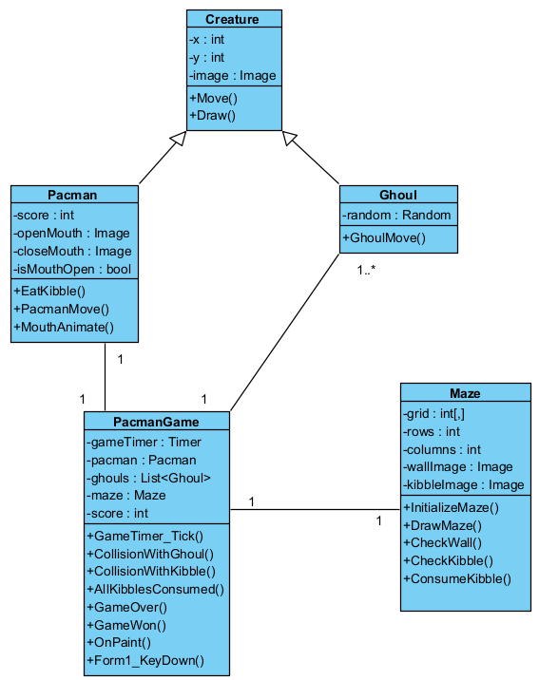

Methods:

Creature

* Move()
* Draw()

Pacman

* EatKibble()
* PacmanMove()
* MouthAnimate()

Ghoul

* GhoulMove()

Maze

* DrawMaze()
* CheckWall()
* CheckKibble()
* ConsumeKibble()

Pacmangame(form1)

* GameTimer_Tick()
* CollisionWithGhoul()
* CollisionWithKibble()
* AllKibblesConsumed()
* GameOver()
* GameWon()
* Form1_KeyDown()

 Fields:

Creature

* x: int
* y: int
* image: Image

Pacman

* score: int
* openMouth: Image
* closeMouth: Image
* isMouthOpen: bool

Ghoul

* random: Random

Maze

* grid: int[,]
* rows: int
* columns: int
* wallImage: Image
* kibbleImage: Image

Form 1

* gameTimer: Timer
* pacman: Pacman
* ghouls: List<Ghoul>
* maze: Maze
* score: int

**Step 5: Iterative Refinement**

Purpose of each method:

Move() – It will be used to move both Pacman and Ghoul with it’s specific movement for each creature.

Draw() – It will draw the creature at it’s relevant position.

EatKibble() – It will increase the Pacman’s score by 1 when it eats each kibble.

PacmanMove() – It will override the move method for the Pacman.

MouthAnimate() – It will set the Pacman’s mouth for animation.

GhoulMove() – It will override the move method for the Ghoul.

InitializeMaze() – It will set up the maze with walls and kibbles.

DrawMaze() – It will draw the maze on the form.

CheckWall() – It will check if the cell is a wall.

CheckKibble() – It will check if the cell is a kibble.

ConsumeKibble() – It will mark a kibble when it’s consumed by Pacman.

GameTimer_Tick() – It will handle the timer tick event.

CollisionWithGhoul() – It will check the collision between Pacman and Ghoul.

CollisionWithKibble() – It will check the collision between Pacman and Kibble.

AllKibblesConsumed() – It will check if all the kibbles are consumed in the maze.

GameOver() – It will handle the game over scenario.

GameWon() – It will handle the game won scenario.

OnPaint() – It will draw the game components on the form.

Form1_KeyDown() – It will move the Pacman using the arrow keys